## horizontal line

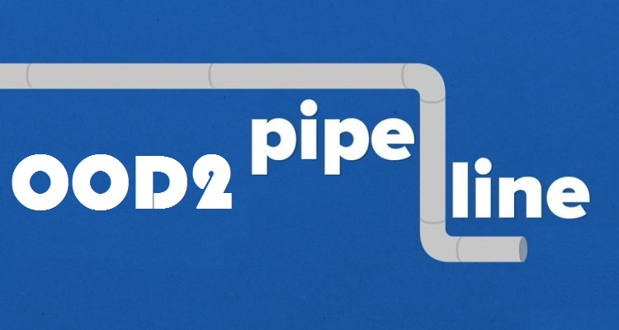

Process Report

Final Version

Date

12 - June - 2017.

OOD2 group

Team (names and student number)

Hoang Linh - 2233495

Fei Pei- 2585413

Simon Onumajuru - 2727897

Xiankuan Peng - 2624109

# **TABLE OF CONTENTS**

**TABLE OF CONTENTS** **2**

**Group decisions** **3**

**Division of labor** **4**

Group tasks: 4

· URS 4

· Design document (class diagram, sequence diagrams) 4

· This document (process report) 4

Individual tasks: 4

· Hoang Linh 4

o Coding of the agreed upon classes (following Use Case) 4

· Simon Onumajuru 4

o Coding of the agreed upon classes (following Use Case) 4

· Fei Pei 5

o Coding of the agreed upon classes (following Use Case) 5

· Xiakuan Peng 5

o Coding of the agreed upon classes (following Use Case) 5

**Personal views on the assignment** **6**

Hoang Linh 6

Simon 6

Fei Pei 6

Xiankuan Peng 6

# 

# 

# 

# 

# 

# 

# Group decisions

Among all our decisions, here are the ones that were most important:

. The user will be notified if the flow is too big since there is a capacity flow range and if exceeded user is being notified right away and this goes for a Pipeline and a Pump.

.(**Extra**) Add new pipeline, we can select way points and then draw them on the canvas

.**Applicable to UC-11 and UC-12**:

We didn’t have New and Close porject which was important and crucial since user or actor has to be able to oepn or close a project.

. **Applicable to UC-02**: user will make use of a numeric-updown selection to be able to select ranges.

.**Applicable to UC-01**, we made amends from error the canvas is what is displayed to the actor not main panel.

.**Applicable to UC-02**, MSS 5 actor draws by click on the component on the toolbox such he knows which component he is drawing or adding to the canvas screen.

.**Applicable to UC-03** and 05, MSS 2 formerly actor choose to remove from list but we changed it to actor just rights clicks and component/pipeline is removed no actions are shown.

.**Applicable to UC-06**, formerly system shows pump configuration panel we later changed into the configuration panel is hidden so on selecting the pump and afterwards user selects a pump to connect then the configuration box appears (is made visible).

.**Applicable to UC-10**, formerly user could work on same file and make changes which will change the other same file but we amended made sure that user can only open different projects and for same project only once.

.**Applicable to UC-08**, we extended the uc into another Save as or Save since the user might want to close the app, or save to exit or have conflicts while saving for the same name so we modified with the updated URS and our application.

.**Applicable to UC-09**, formerly was to export both in PDF and PNG but we later decided to just export in PNG format.

**.Applicable to UC-06,**

**.Applicable to UC-04**, should allow the changing of the pump flow when the application is already running but we couldn’t succeed and decided to implement it at the initial selection of the component that s ony possible when selecting at first start.

Also we set the percentage of the adjustable splitter to default of 50% but user cna modify or change anytime.

.**Applicable to UC-02**, formerly actor enters current/max flow but we decideed to change into a default max flow capacity such that when actor click on pipeline a menus pops out on which he can then set max or current flow capacity.

.**Applicable to all UC:** for modifying, deleting or changing flows, capacity, etc we change into a right click which pops out a menu or displays and option between delete or properties(change flow pump, or flow/max capacity)

We added an extra class called Pipe class to achieve waypoint function.

Pipe class stores a Line segment, with startpoint and end point. Each pipelines could have a list of pipe

We made use of Events and Delegates because this will reduce a lot type checking(if if ….) in the panel1 click event.

We made us of the Point class because to make classes more clean and more convenient when using drawing functions.

We added a new form called Form properties to the solution used for displaying the max flow, capacity, percentage when use using the right click to display the properties, and it would be more user-friendly.

# 

# Division of labor

### Group tasks:

### · URS

### · Design document (class diagram, sequence diagrams)

### · This document (process report)

### **Individual tasks:**

### · **Hoang Linh**

### o Coding of the agreed upon classes (following Use Case)

* URS
* Form Design
* Add Component functions
* Add Pipeline functions
* Flow Calculation
* Remove component

### · **Simon Onumajuru**

### o Coding of the agreed upon classes (following Use Case)

* URS
* Save and Load project
* Export PNG
* Change flow percentage of adjustable splitter
* Class Diagram
* Class Description
* Sequence Diagram

### · **Fei Pei**

### o Coding of the agreed upon classes (following Use Case)

* URS
* Sequence Diagram
* Class Diagram

### · **Xiakuan Peng**

### o Coding of the agreed upon classes (following Use Case)

* URS
* Sequence Diagram
* Remove pipeline
* Change a current flow of a pump (URS)
* Change flow percentage of adjustable splitter

# 

# 

# Personal views on the assignment

## **Hoang Linh**

### The project was comprehensive, the works are divided to both documentation and programming. I’ve learnt a lot about team dynamic and teamwork. I faced some problems where my teammates were not in the same page with me, but we discussed and solved the problem.

### The application was very heavy focused on how to declare methods and different approaches to solve a problem. I’ve learnt advantages and disadvantages of my methods from both teammates and teacher.

## **Simon**

### This is the first time I do a group job in Object-Oriented programming, i’m glad I could participate and have such an experience. I learned many things during these weeks, a further understanding of C# development, documentation very important, communicating with teammates and so on. All of these are treasure alot.

### Importance of this project

### This is a good start, I had a further understanding of the Object-Oriented programming and teamwork. There’s no doubt about this project for it is a valuable experience for me and for my future career.

## **Fei Pei**

### 

## **Xiankuan Peng**

This object oriented design project experience is much more different with my previous projects’ experiences. Through this project, i realized a significant increase on the efficiency of programming by designing before start programing which i was not used to.Mean while,this project pushes my boundary of my skills and knowledge get practiced.

Besides that, this project also makes me realized my weakness and i fix some of them during the cooperation with other teammates, and i would count this as the most valuable acquisition.

### 

# 